# Assignment 4 – Dice

[*Submit on Blackboard*](https://blackboard.usc.edu/)

## Goals

* Connect LEDs to Argon
* Use push button for analog input
* Use built-in libraries to generate random numbers
* Use C++ arrays

Overview

This assignment is to create an electronic die. When a button is pressed, the die will be “rolled” and a new value will appear. The die roll will be simulated by generating a random number 1-6

Here is an example:

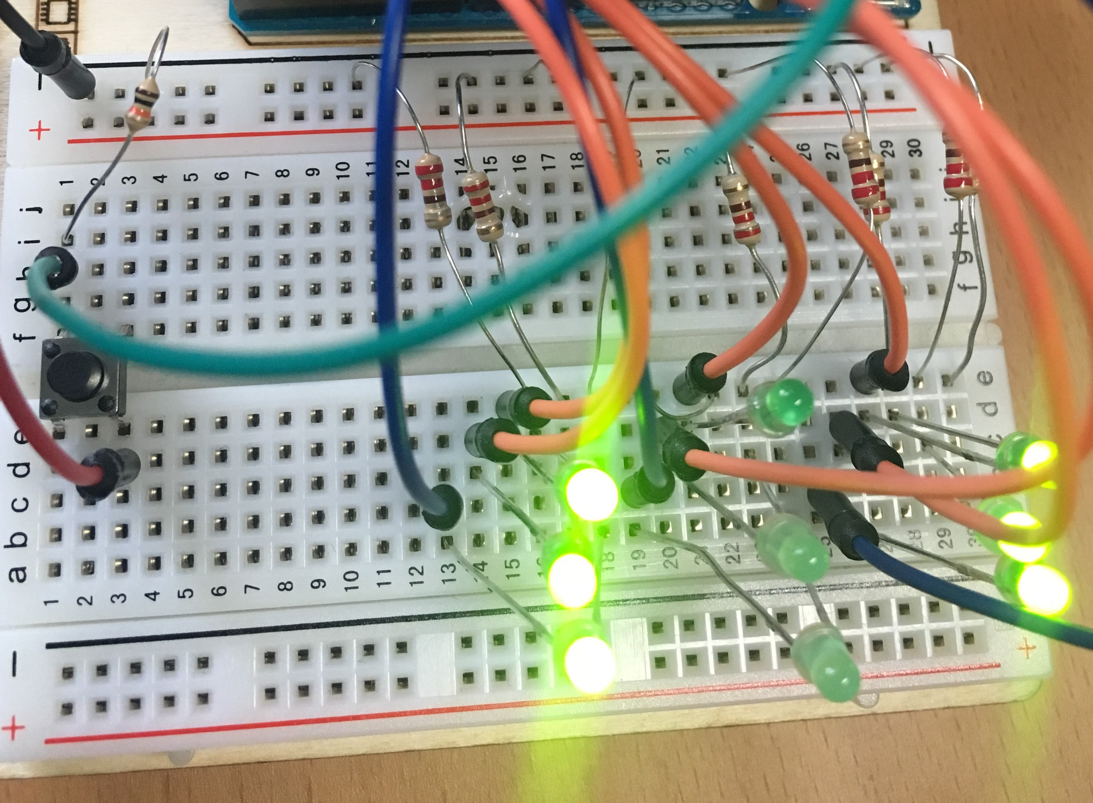

The die value can be represented by a 3x3 grid of LED lights as follows:

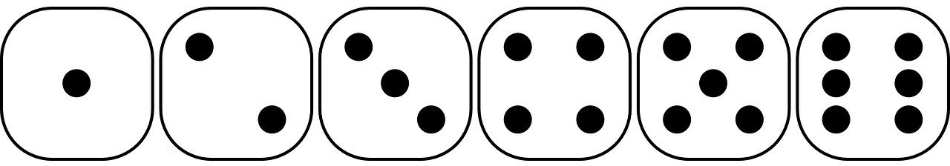

Components

* Argon
* Breadboard
* 9 x LEDs
* 9 x resistors *(what value should you use?)*
* 1 push button
* Jumper wire (standard male-male)

Requirements

* Create a Fritzing breadboard prototype layout of your design
* Once you’re satisfied with the design, connect the device
* When turned counter-clockwise, the lights should be very dim and blinking slowly
* **Hint:** the state of each die value (which lights are on and off) can be represented as a 3x3 matrix (2 dimensional array / list. However, an easier way to think about this is as a 9-element array / list. You should create 6 **const int** arrays that represent patterns for each die value.

Required naming convention (replace # with the current assignment number)

* **Project Name** 
  + itp348_a#_lastname_firstname
* **Zip File** (include entire project folder)
  + itp348_a#_lastname_firstname.zip

## Deliverables

1. A compressed file containing your project. Follow the guidelines for full credit.

Here are the instructions for submission

1. Navigate to your project folder.
2. Include the *entire* folderin a zip file
3. Rename the zip file based on naming convention
4. Upload zip file to Blackboard site for our course
5. A photograph of your device connected to USB with the blue light on.
6. A (very) short video demonstrating your project functioning

## Grading

|  |  |
| --- | --- |
| Item | Points |
| Fritzing layout | 5 |
| 9 LEDS connected correctly | 5 |
| Button press changes lights | 10 |
| Die value patterns stored as arrays | 10 |
|  |  |
| Total | 30 |

**Credits**

* Image by [Clker-Free-Vector-Images](https://pixabay.com/users/Clker-Free-Vector-Images-3736/?utm_source=link-attribution&amp;utm_medium=referral&amp;utm_campaign=image&amp;utm_content=26772) from [Pixabay](https://pixabay.com/?utm_source=link-attribution&amp;utm_medium=referral&amp;utm_campaign=image&amp;utm_content=26772)
* Inspiration for project from [Dr. Peter Dalmaris](https://www.udemy.com/course/arduino-step-by-step-2017-getting-started-projects/)